**CYCLE - 3**

**1. Area of different shapes using overloaded functions**

**Code:**

import java.util.Scanner;

public class Overload {

void calculateArea(float x) {

System.out.println("Area of the square: "+x*x+ "sq units");

}

void calculateArea(float x, float y) {

System.out.println("Area of rectangle: " +x*y+ "sq units");

}

void calculateArea(double r) {

double area = 3.14*r*r;

System.out.println("Area of the circle: " +area+ "sq units");

}

public static void main(String args[]) {

System.out.println("Name: Denzel Sunny");

System.out.println("Addmission_no: 22MCA022");

System.out.println("Course ID & Code : OOP LAB, 20MCA132");

System.out.println("Date: 2/05/2023");

System.out.println("____________________________________\n\n");

Overload obj = new Overload();

System.out.println("Enter the side of the square: ");

Scanner sc = new Scanner(System.in);

float side = sc.nextFloat();

obj.calculateArea(side);

System.out.println("Enter sides of the rectangle: ");

float side1 = sc.nextFloat();

float side2 = sc.nextFloat();

obj.calculateArea(side1, side2);

System.out.println("Enter the radius of the circle: ");

double rad = sc.nextDouble();

obj.calculateArea(rad);

}

}

**Output:**

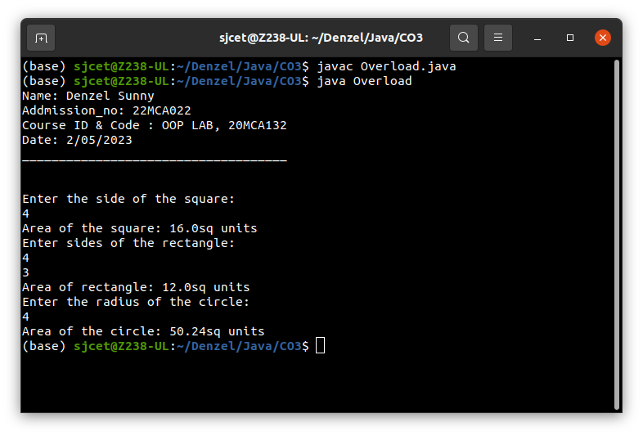

**2. Create a class ‘Employee’ with data members Empid, Name, Salary, Address and constructors to initialize the data members. Create another class ‘Teacher’ that inherit the properties of class employee and contains its own data members department, Subjects taught and constructors to initialize these data members and also include a display function to display all the data members. Use an array of objects to display details of N teachers.**

**Code:**

import java.util.Scanner;

class Employees {

int Empid;

String Name;

double Salary;

String Address;

Employees(int no, String na, double sal, String add) {

this.Empid = no;

this.Name = na;

this.Salary = sal;

this.Address = add;

}

}

class Teacher extends Employees{

String dept;

String subject;

Teacher(int no, String na, double sal, String add, String dept, String sub){

super(no,na,sal,add);

this.dept= dept;

this.subject=sub;

}

void display(){

System.out.println("Employee id: "+Empid);

System.out.println("Name: "+Name);

System.out.println("Salary: "+Salary);

System.out.println("Address: "+Address);

System.out.println("Department: "+dept);

System.out.println("Subject: "+subject);

}

public static void main(String[] args) {

System.out.println("Name: Denzel Sunny");

System.out.println("Addmission_no: 22MCA022");

System.out.println("Course ID & Code : OOP LAB, 20MCA132");

System.out.println("Date: 5/05/2023");

System.out.println("____________________________________\n\n");

System.out.println("Enter the No. of Employee's");

Scanner sc1 = new Scanner(System.in);

int num = sc1.nextInt();

Teacher arr[]=new Teacher[num];

for(int i =0;i<num;i++)

{

Scanner sc =new Scanner(System.in);

System.out.println("Enter Employee id: ");

int Empid=sc.nextInt();

System.out.println("Enter Employee Name: ");

String Name=sc.next();

System.out.println("Enter Salary: ");

double Salary=sc.nextDouble();

System.out.println("Enter Address: ");

String Address=sc.next();

System.out.println("Enter department: ");

String dept=sc.next();

System.out.println("Enter Subject: ");

String subject=sc.next();

arr[i]=new Teacher(Empid,Name,Salary,Address,dept,subject);

}

System.out.println("\n********Informations of all the employee's************");

for(int i=0;i<num;i++){

int j=i+1;

System.out.println("\n"+j+").");

arr[i].display();

}

sc1.close();

}

}

**Output:**

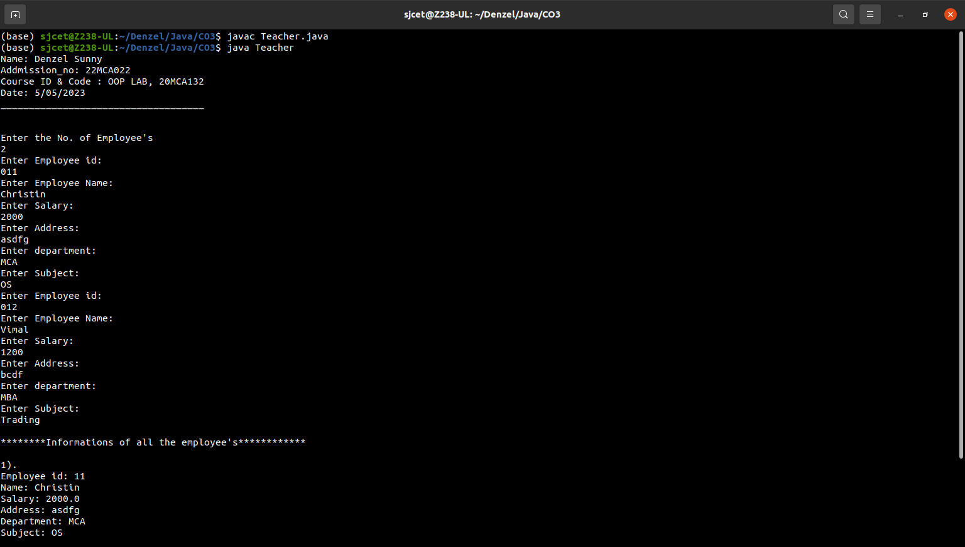

**3. Create a class ‘Person’ with data members Name, Gender, Address, Age and a constructor to initialize the data members and another class ‘Employee’ that inherits the properties of class Person and also contains its own data members like Empid, Company_name, Qualification, Salary and its own constructor. Create another class ‘Teacher’ that inherits the properties of class Employee and contains its own data members like Subject, Department, Teacherid and also contain constructors and methods to display the data members. Use array of objects to display details of N teachers.**

**Code:**

import java.util.Scanner;

class person {

String Name;

String Gender;

String Address;

int Age;

person(String name,String gender,String address, int age) {

this.Name = name;

this.Gender = gender;

this.Address = address;

this.Age = age;

}

}

class Employee extends person

{

int Empid;

String Company_name;

String Qualification;

long Salary;

Employee(String name,String gender,String address, int age,int empid, String company_name, String qualification,long salary)

{

super(name,gender,address,age);

this.Empid= empid;

this.Company_name=company_name;

this.Qualification=qualification;

this.Salary=salary;

}

}

class Teacher2 extends Employee{

String Subject;

String Department;

String Teacherid;

Teacher2(String name,String gender,String address, int age,int empid, String company_name, String qualification,long salary, String subject, String department, String teacherid){

super(name,gender,address,age,empid,company_name,qualification,salary);

this.Subject=subject;

this.Department=department;

this.Teacherid=teacherid;

}

void display(){

System.out.println("Name: "+Name);

System.out.println("Gender: "+Gender);

System.out.println("Address: "+Address);

System.out.println("Age: "+Age);

System.out.println("Employee id: "+Empid);

System.out.println("Company Name: "+Company_name);

System.out.println("Qualification: "+Qualification);

System.out.println("Salary: "+Salary);

System.out.println("Subject: "+Subject);

System.out.println("Department: "+Department);

System.out.println("Teacher id: "+Teacherid);

}

public static void main(String[] args) {

System.out.println("Name: Denzel Sunny");

System.out.println("Addmission_no: 22MCA022");

System.out.println("Course ID & Code : OOP LAB, 20MCA132");

System.out.println("Date: 7/06/2023");

System.out.println("____________________________________\n");

System.out.println("Enter the No. of Teacher's");

Scanner sc1 = new Scanner(System.in);

int num = sc1.nextInt();

Teacher2 arr[]=new Teacher2[num];

System.out.println(" Enter the Teacher Details");

int x = 0,j=0;

Scanner sc =new Scanner(System.in);

for(int i =0;i<num;i++)

{

x = i +1;

System.out.println(""+x+").");

System.out.println(" Name: ");

String a =sc.next();

System.out.println(" Gender: ");

String b =sc.next();

System.out.println(" Address: ");

String c =sc.next();

System.out.println(" Age: ");

int d =sc.nextInt();

System.out.println(" Employee id: ");

int e =sc.nextInt();

System.out.println(" Company name: ");

String f =sc.next();

System.out.println(" Qualification: ");

String g =sc.next();

System.out.println(" Salary: ");

long h =sc.nextLong();

System.out.println(" Subject: ");

String k =sc.next();

System.out.println(" Department: ");

String l =sc.next();

System.out.println(" Teacher Id: ");

String n =sc.next();

arr[i]=new Teacher2(a,b,c,d,e,f,g,h,k,l,n);

}

sc.close();

System.out.println("********Informations of all the Teacher's************");

for(int i=0;i<num;i++){

j=i+1;

System.out.println("\n"+j+").");

arr[i].display();

}

sc1.close();

}

}

**Output:**

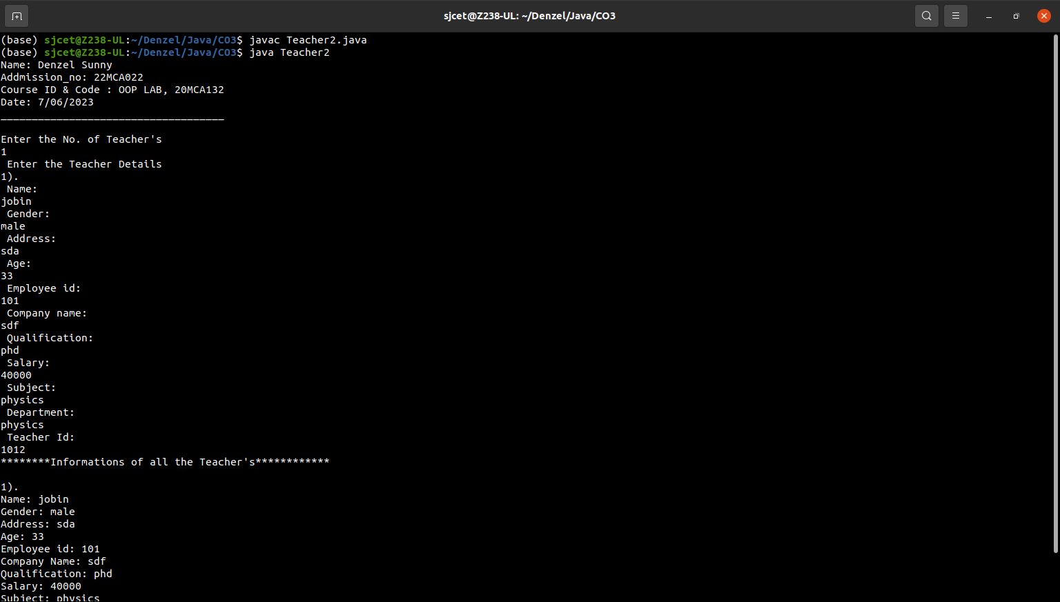

**4. Write a program has class Publisher, Book, Literature and Fiction. Read the information and print the details of books from either the category, using inheritance.**

**Code:**

import java.util.Scanner;

class Publisher{

String publisher;

Publisher(String pub){

this.publisher=pub;

}

}

class Book extends Publisher{

String book;

Book(String pub, String boo){

super(pub);

book=boo;

}

}

class Literature extends Book{

String category;

Literature(String pub, String boo){

super(pub, boo);

}

void display(){

System.out.println("Publisher : "+publisher);

System.out.println("Book : "+book);

}

}

class Fiction extends Book{

Fiction(String pub, String boo){

super(pub, boo);

}

void display(){

System.out.println("Publisher : "+publisher);

System.out.println("Book : "+book);

}

}

public class Bookdetails{

public static void main(String[] args){

System.out.println("Name: Denzel Sunny");

System.out.println("Addmission_no: 22MCA022");

System.out.println("Course ID & Code : OOP LAB, 20MCA132");

System.out.println("Date: 7/06/2023");

System.out.println("____________________________________\n");

System.out.println("Enter the No. of Literature Books");

Scanner sc1 = new Scanner(System.in);

int num = sc1.nextInt();

Literature arr[]=new Literature[num];

System.out.println("Enter the Literature Book details");

int x = 0,j=0;

Scanner sc = new Scanner(System.in);

for(int i=0; i<num; i++)

{

x = i+1;

System.out.println("\n"+x+").");

System.out.println("Book : ");

String boo =sc.nextLine();

System.out.println("Publisher : ");

String pub =sc.nextLine();

arr[i]=new Literature(boo, pub);

}

System.out.println("Enter the No. of Fiction Books");

int num1 = sc1.nextInt();

Fiction arr1[]=new Fiction[num1];

System.out.println(" Enter the Fiction Book Details");

int x1 = 0,j1=0;

for(int i =0;i<num1;i++)

{

x1 = i +1;

System.out.println("\n"+x1+").");

System.out.println(" Book : ");

String boo =sc.nextLine();

System.out.println(" Publisher: ");

String pub =sc.nextLine();

arr1[i]=new Fiction(boo,pub);

}

sc.close();

sc1.close();

System.out.println("********Informations of all the Literature Books************");

for(int i=0;i<num;i++){

j=i+1;

System.out.println("\n"+j+").");

arr[i].display();

}

System.out.println("********Informations of all the Fiction Books************");

for(int i=0;i<num1;i++){

j1=i+1;

System.out.println("\n"+j1+").");

arr1[i].display();

}

sc1.close();

}

}

**Output:**

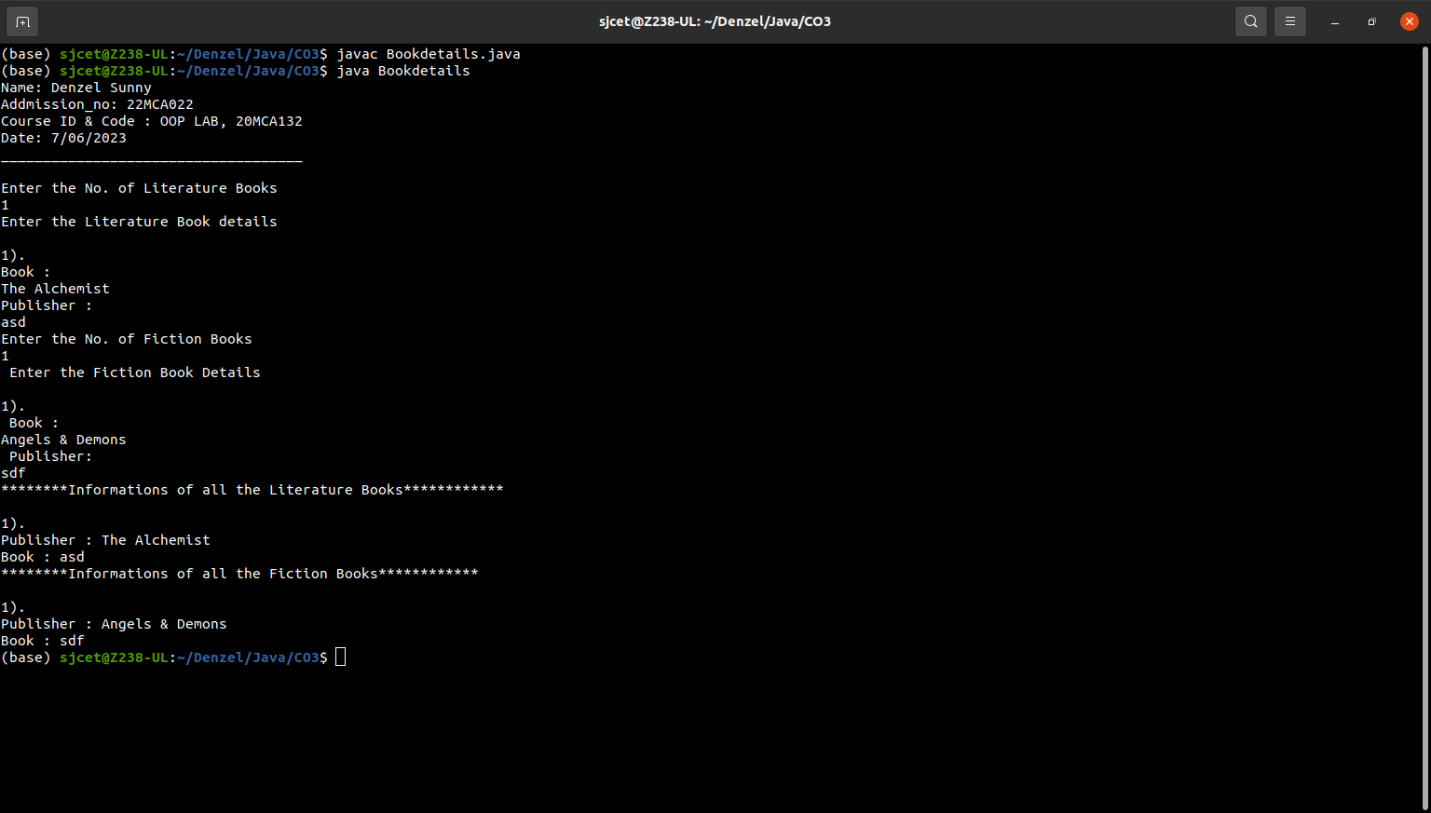

**5. Create classes Student and Sports. Create another class Result inherited from Student and Sports. Display the academic and sports score of a student.**

**Code:**

import java.util.Scanner;

class sports{

String sport;

int Rating;

sports(String spo, int rat){

sport = spo;

Rating = rat;

}

}

class student extends sports{

String Grade;

double Overall_per;

student(String spo, int rat,String gd, double per ){

super(spo, rat);

Grade = gd;

Overall_per = per;

}

}

public class Result extends student {

Result(String spo, int rat,String gd, double per ){

super(spo, rat, gd, per);

}

void display(){

System.out.println("Sports Details of Student");

System.out.println("Sport :"+sport);

System.out.println("Rating :"+Rating);

System.out.println("Academic Details of Student");

System.out.println("Academic Grade :"+Grade);

System.out.println("Overall percentage :"+Overall_per);

}

public static void main(String[] args) {

System.out.println("Name: Denzel Sunny");

System.out.println("Addmission_no: 22MCA022");

System.out.println("Course ID & Code : OOP LAB, 20MCA132");

System.out.println("Date: 7/06/2023");

System.out.println("____________________________________\n");

Scanner sc =new Scanner(System.in);

System.out.println("Enter the Sports Details of Student");

System.out.println(" Sport: ");

String a =sc.nextLine();

System.out.println(" Sport Rating out of 10: ");

int b =sc.nextInt();

System.out.println("Enter the Sports Details of Student");

System.out.println(" Academic Grade: ");

String c =sc.next();

System.out.println(" Overall percentage: ");

double d =sc.nextDouble();

sc.close();

Result obj= new Result(a,b,c,d);

obj.display();

}

}

**Output:**

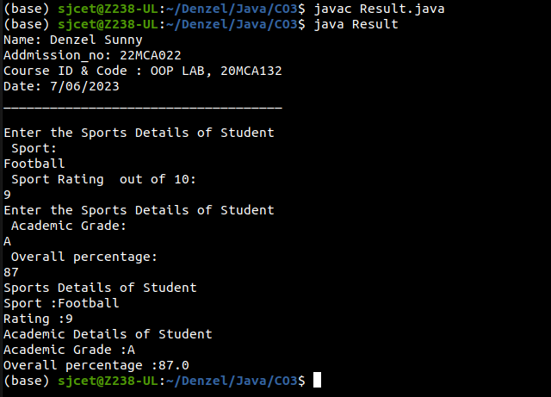

**6. Create an interface having prototypes of functions area() and perimeter(). Create two classes Circle and Rectangle which implement the above interface. Create a menu driven program to find the area and perimeter of objects.**

**Code:**

import java.util.Scanner;

interface prop

{

void getdata();

void area();

void perimeter();

}

class Circle implements prop

{

double pi = 3.14;

double r;

Scanner sc = new Scanner(System.in);

@Override

public void getdata()

{

System.out.println("Enter the radius of the circle:");

r = sc.nextDouble();

}

@Override

public void perimeter()

{

System.out.println("Perimeter of the circle: "+(2*pi*r));

}

@Override

public void area()

{

System.out.println("area of the circle: "+(pi*r*r));

}

}

class Rectangle implements prop

{

double l,b;

Scanner sc = new Scanner(System.in);

@Override

public void getdata()

{

System.out.println("Enter the length of the rectangle:");

l = sc.nextDouble();

System.out.println("Enter the breadth of the rectangle:");

b = sc.nextDouble();

}

@Override

public void area()

{

System.out.println("area of a rectangle: "+(l*b));

}

@Override

public void perimeter()

{

System.out.println("Perimeter of a rectangle: "+(2*(l+b)));

}

}

public class Dimension

{

public static void main(String[] args)

{

System.out.println("Name: Denzel Sunny");

System.out.println("Addmission_no: 22MCA022");

System.out.println("Course ID & Code : OOP LAB, 20MCA132");

System.out.println("Date: 7/06/2023");

System.out.println("____________________________________\n");

int ch;

Scanner sc = new Scanner(System.in);

Circle ob = new Circle();

Rectangle obj = new Rectangle();

do

{

System.out.println("\n1.Circle\n2.Rectangle\n3.exit");

System.out.println("Enter your choice:");

ch = sc.nextInt();

switch(ch)

{

case 1 :ob.getdata();

ob.area();

ob.perimeter();

break;

case 2 :obj.getdata();

obj.area();

obj.perimeter();

break;

case 3 :System.out.println("Exited...");

System.exit(0);

}

}while(true);

}

}

**Output:**

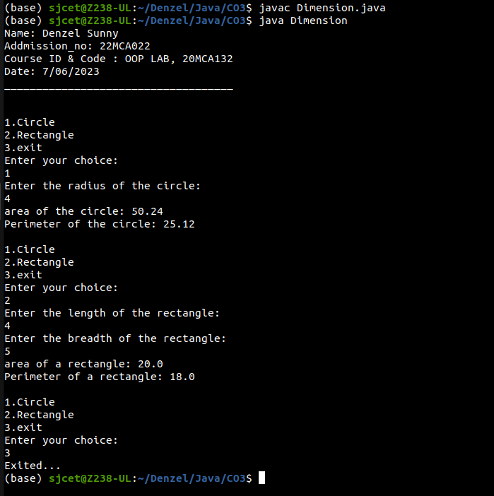

**7. Prepare bill with the given format using calculate method from interface.**

**Order No.**

**Date :**

**Product Id Name Quantity unit price Total**

**—-----------------------------------------------------------------------------------------**

**101 A 2 25 50**

**102 B 1 100 100**

**—-----------------------------------------------------------------------------------------**

**Net. Amount 150**

**Code:**

import java.util.Scanner;

interface calc

{

void calculate();

}

class bill implements calc

{

String date,name,p_id;

int quantity;

double unit_price,total,namount=0;

Scanner sc = new Scanner(System.in);

public void getdata()

{

System.out.println("Enter product id:");

p_id = sc.nextLine();

System.out.println("Enter product name:");

name = sc.nextLine();

System.out.println("Enter the Quantity:");

quantity = sc.nextInt();

System.out.println("Enter the unit price:");

unit_price = sc.nextDouble();

}

@Override

public void calculate()

{

total = quantity * unit_price;

}

public void display()

{

System.out.println(p_id+"\t\t"+name+"\t\t"+quantity+"\t\t"+unit_price+"\t"+total);

}

}

public class Ebill

{

public static void main(String[] args)

{

System.out.println("Name: Denzel Sunny");

System.out.println("Addmission_no: 22MCA022");

System.out.println("Course ID & Code : OOP LAB, 20MCA132");

System.out.println("Date: 7/06/2023");

System.out.println("____________________________________\n");

int n,i;

double namount=0,t;

int ran;

String date;

t = Math.random() *1000000;

ran = (int) t;

Scanner sc = new Scanner(System.in);

System.out.println("Order no. #"+ran);

System.out.println("Enter the date:");

date = sc.nextLine();

System.out.println("Enter how many products are there:");

n = sc.nextInt();

bill ob[] = new bill[n];

for(i=0;i<n;i++)

ob[i] = new bill();

for(i=0;i<n;i++){

ob[i].getdata();

ob[i].calculate();

}

System.out.println("Date:"+date);

System.out.println("Product Id \tName\t Quantity\t unit price\t Total ");

System.out.println("--------------------------------------------------------------");

for(i=0;i<n;i++){

ob[i].display();

namount += ob[i].total;

}

System.out.println("--------------------------------------------------------------");

System.out.println("\t\t\tNet.Amount\t"+ namount);

}

}

**Output:**

